13.64: (a) Momentum conservation during the collision: 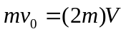

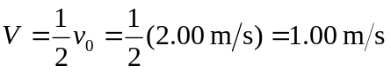

Energy conservation after the collision:

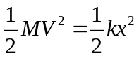

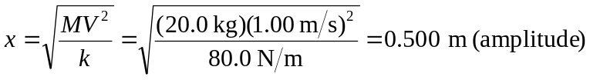

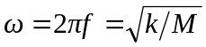

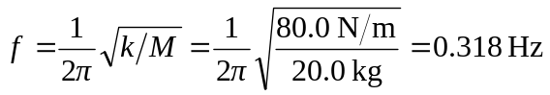

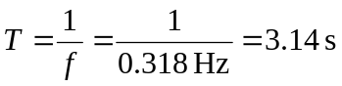

(b) It takes 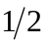 period to first return: 